**CMPE 297 – Special Topics in Software Engineering**

**FALL 2017**



**IOS Application Development**

**Assignment 3 - IOS Map Kit Assignment**

**Submitted by- Submitted to-**

Anvit Saxena Prof. Chandrashekhar

SJSU ID: 010953436

1. Created an iOS app using XCode tool. Below is the project structure as shown on the left hand side. It has three view controllers and one Main storyboard.

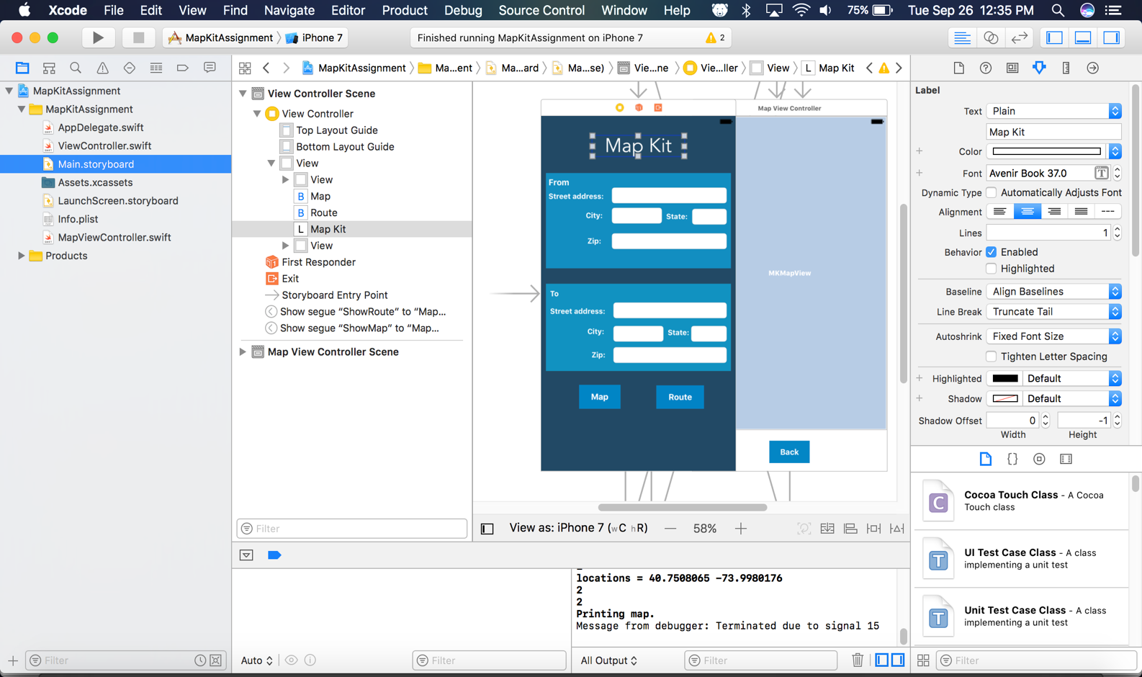

1. Once the application is run using iPhone 7 Emulator below is the welcome screen or Main storyboard that opens up for user to enter the details:

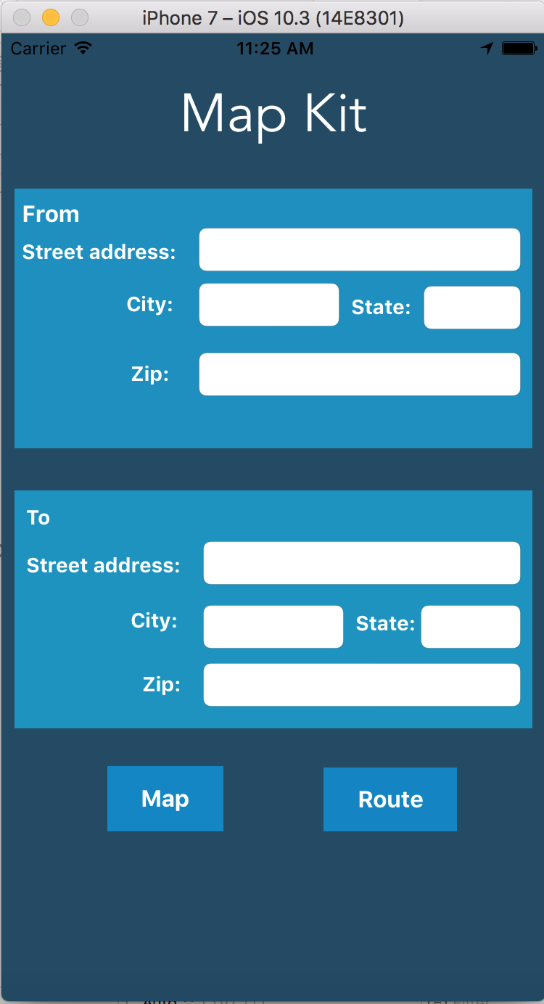

1. As we can see in the screenshot, user has an option to either see the Map with both the from and to address using Map button. Or user can see the route for the same using Route button. In below screenshot user enters the from and to addresses and clicks on Route button to see its route.

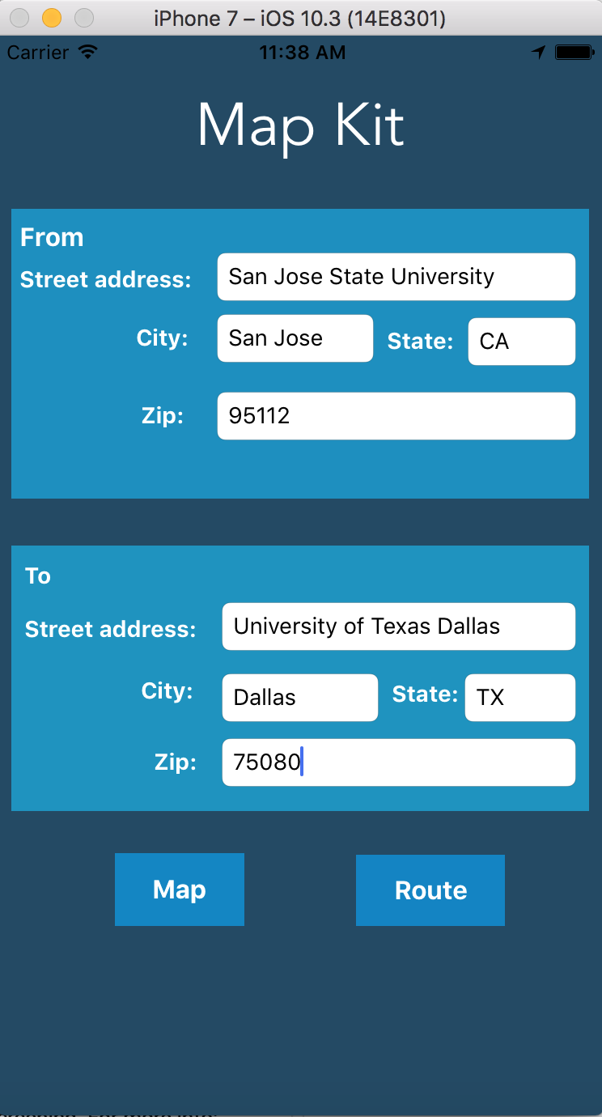

Once the route button is clicked, the map opens up with the two pointers. One pointing for To address and other pointing to From address. And there is a polyline in blue colour which is used to show the route between both the addresses as shown below:

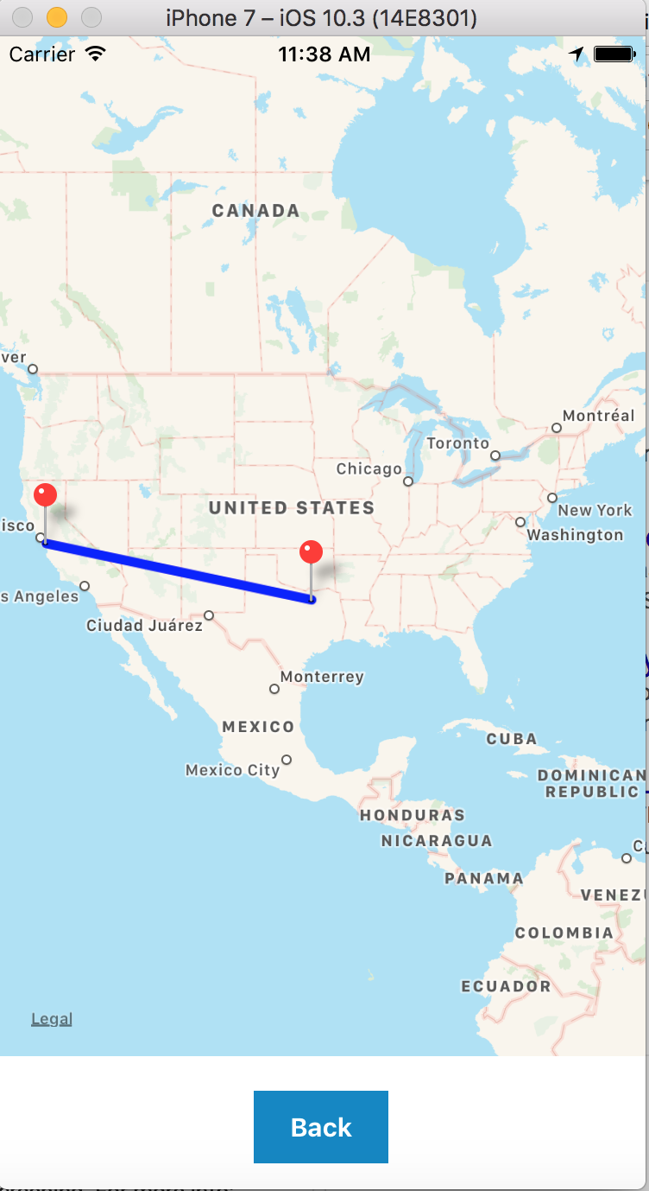

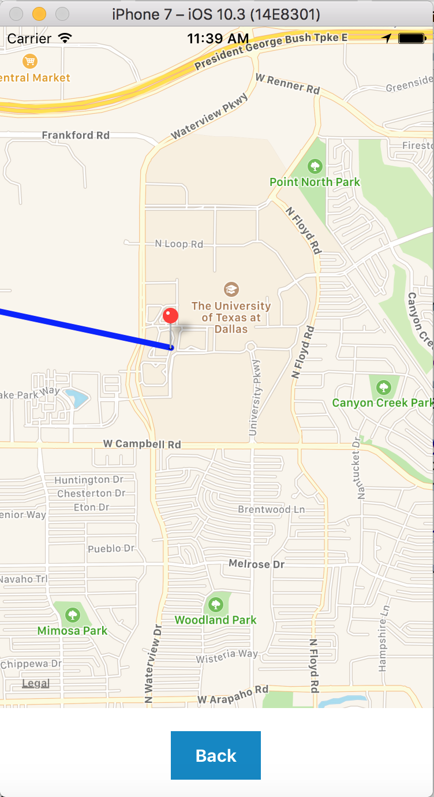

This shows the To address when zoomed in.

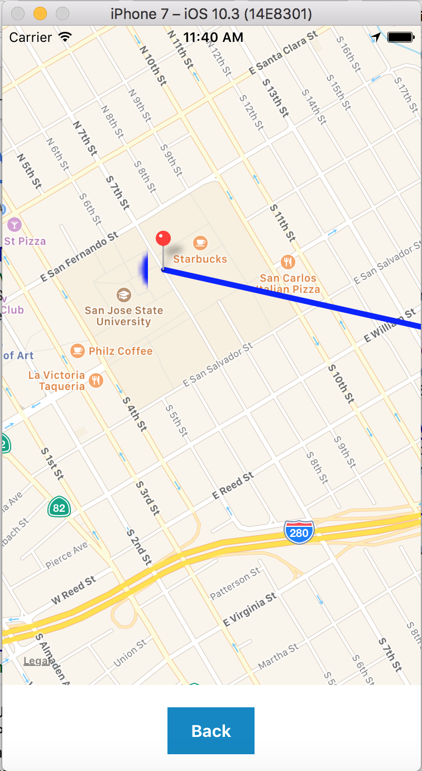

This shows the From address when zoomed in.

1. Now when user clicks on back button, it goes back to the home page. Now we can see how a Map is displayed with two pointers when user just selects the Map button after entering both the address.

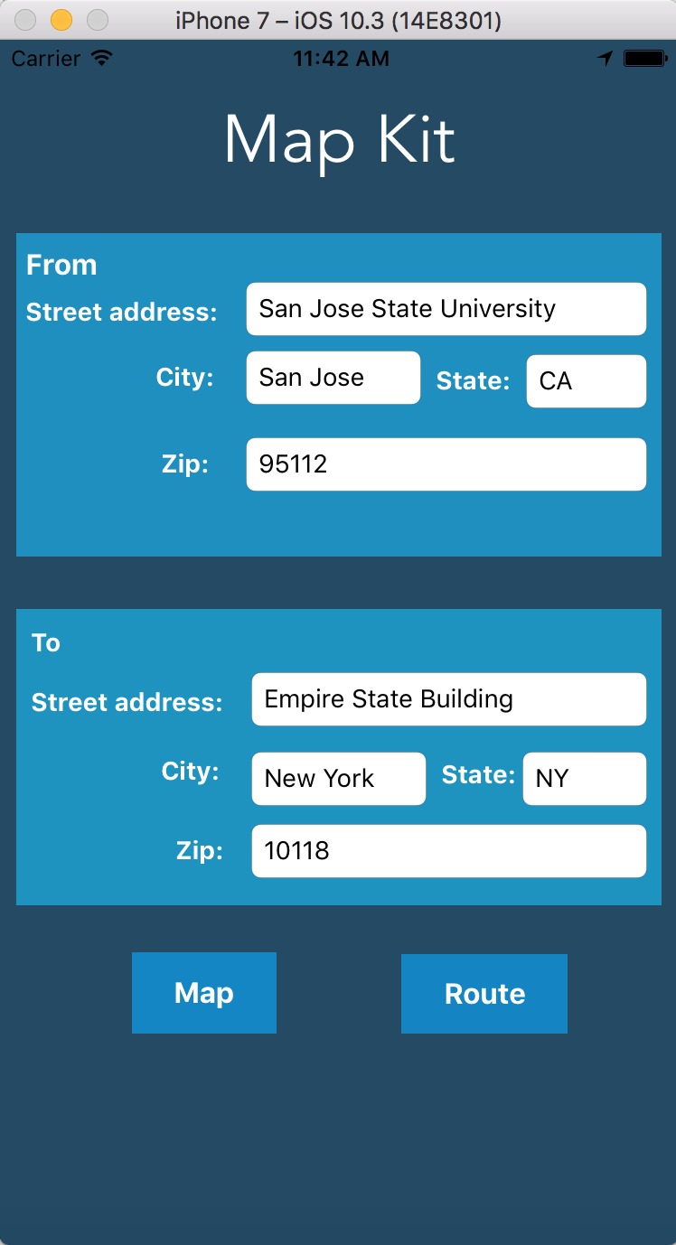

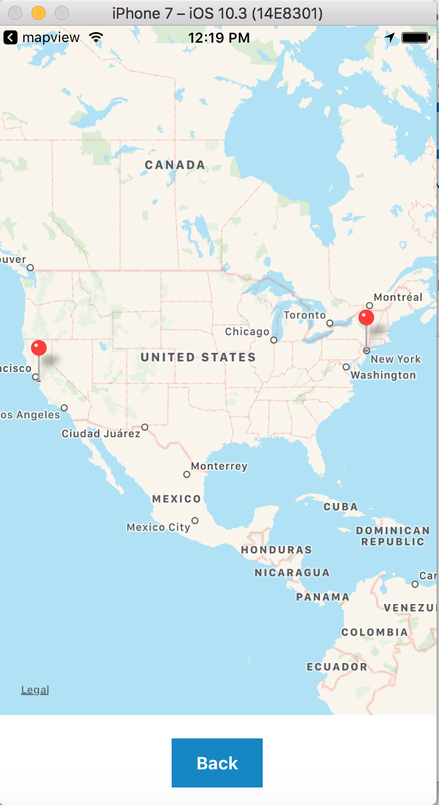

This is applicable even when user enters only one address. In that case only one pointer will be displayed in the map.